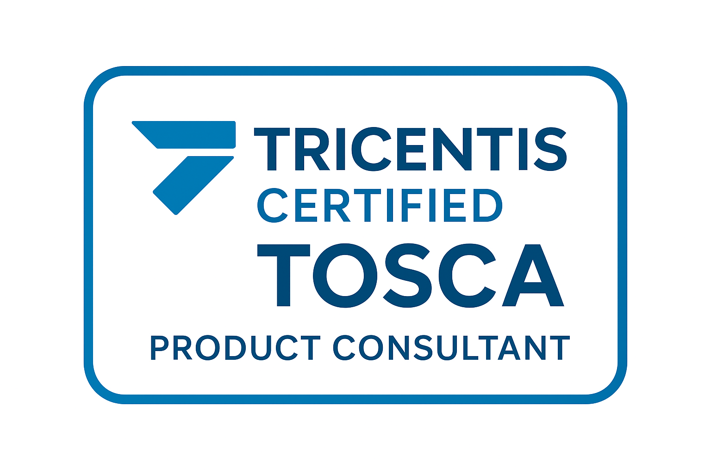
R. RAJESH
rrdqa.sh1@gmail.com
832-286-9293
Dallas, TX 75038
Summary

- Over 15+ years of experience in ETL (Extract, Transform, Load) development, data integration, and data warehousing using Informatica PowerCenter (versions 8.x–10.x).
- Skilled in data modeling, data mapping, data profiling, and performance tuning for large-scale enterprise systems.
- Proficient in SQL, PL/SQL, Oracle, and HANA databases, ensuring optimized data extraction and transformation processes.
- Experienced in Business Intelligence and Decision Support Systems with hands-on expertise in Informatica, Oracle, and related tools.
- Strong ability to analyze business requirements, design end-to-end ETL workflows, and implement scalable, high-quality data pipelines.
- Skilled in error handling, data cleansing, and data validation to ensure data integrity and consistency across systems.
- Collaborated with business analysts, data architects, and QA teams to ensure seamless delivery of data solutions.
- Adept at collaborating with cross-functional teams to deliver reliable, timely, and business-driven data integration solutions.
- Committed to process automation, data accuracy, and continuous improvement in data operations and reporting.
- Certified TOSCA Automation Tester with hands-on experience in test automation and quality assurance.
- Proficient in Tricentis TOSCA for creating, executing, and maintaining automated test cases across web, desktop, and API applications.
- Strong understanding of software testing life cycle (STLC), test case design, and defect management.
- Skilled in requirement analysis, risk-based testing, and test strategy implementation.
- Experienced in integrating TOSCA with CI/CD pipelines and version control systems like Git.
- Hands-on experience in data-driven testing, test case parameterization, and reusable test components.
- Familiar with Agile/Scrum methodologies and collaborative testing environments.
- Excellent problem-solving skills with a focus on improving test coverage and reducing manual testing effort.

Project

- Developed automated test cases using Tricentis TOSCA for user login validation.
- Implemented reusable modules and data-driven testing to improve test efficiency.
- Managed test cases and version control via GitHub.
- Repository: https://github.com/rajeshranganathan19-cpu/Custom-Framework-Using-TOSCA-For-User-Login-Validation.-
Skills Matrix

ETL Technology & Data Warehouse: | Informatica PowerCenter 10.x//9.x/8.x, Power Exchange 10.x /9.x, IDQ,
Data Modeling: | Star-Schema Modeling, Snowflake Modeling,
Databases: | Oracle 12c/11g/10g, MS SQL Server, SAP HANA, MongoDB
Automation tool: | TOSCA
Environments: | Windows, UNIX, LINUX, MS-DOS
Scheduling and reporting tools | UC4, Control-M, SAP BO
SDLC Methodologies: | Agile, Waterfall
Experience

Santander Consumer USA Dallas, TX  Data Quality Engineer/ETL Testing  09/2021 – Current | - Analyze ETL requirements and data mapping documents to create detailed test plans and test cases.  - Design, develop, and execute manual ETL test cases to validate data transformations, load processes, and business rules.  - Validate data accuracy, completeness, consistency, and integrity between source and target systems.  - Applied advanced technical expertise to develop test data, scripts, and procedures ensuring accuracy, performance, and compliance with business and functional requirements.  - Led testing efforts for post–cloud migration SIT validation, designing and automating heterogeneous database reconciliation test cases using Python and Spark.  - Monitor ETL workflows, report defects, and work with developers to resolve data issues efficiently.  - Ensure proper testing of incremental loads, full loads, and historical data in data warehouses or data marts.  - Document test results, provide status reports, and escalate critical issues to management.  - Participate in UAT (User Acceptance Testing) and support production deployment activities.  - Implement and enforce ETL testing best practices and maintain test repositories for future reference.
Huntsman Corp. | Houston, TX  Senior ETL Tester  02/2018 – 08/2021 | - Designed and executed test cases for ETL workflows using Informatica PowerCenter to validate data extraction, transformation, and loading processes.  - Validated source-to-target data mapping documents and ensured data accuracy across multiple systems.  - Performed data validation testing using SQL queries to verify completeness, correctness, and consistency of data.  - Tested ETL jobs for data integrity, transformation rules, and business logic compliance.  - Wrote complex SQL queries to validate large datasets in databases like Oracle Database, SQL Server, or MySQL.  - Conducted back-end testing to ensure accurate data movement between source and target systems.  - Identified and resolved data discrepancies, duplicates, and data quality issues.  - Tested ETL workflows, mappings, sessions, and workflows for performance and accuracy.  - Validated incremental and full load processes, including CDC (Change Data Capture) logic.  - Performed regression testing after ETL code deployments to ensure stability.  - Worked with scheduling tools like Control-M or Autosys to validate batch jobs.  - Utilized defect tracking tools such as JIRA to log and track bugs.  - Collaborated with developers, business analysts, and data engineers to understand requirements and ensure test coverage.

Deloitte | NM  ETL Informatica Developer  01/2016 - 12/2017 | - Design Develop and Implementation of ETL jobs to load internal and external data into data mart.  - Develop and modify ETL jobs to meet monthly and quarterly report needs.  - Analyzed source data, extracted, transformed, and loaded data in to target data warehouse based on the requirement specification using Informatica PowerCenter.  - Production Support has been done to resolve the ongoing issues and troubleshoot the problems.  - Coordinated and performed moderately complex testing projects from initiation through delivery. Ensured that tested projects are completed on schedule and within budget.  - Assisted the BI developers to fix issues in Hana target table while loading data through informatica.  - Involved in enhancements and maintenance activities of the data warehouse including tuning, modifying of stored procedures for code enhancements.

Accenture, Chennai, INDIA.  Process Lead/ ETL  03/2012 - 12/2013 | - Interpreted and comprehend business/data requirements from upstream processes.  - Worked in doing performance tuning of SQL queries.  - Created and documented source-to-target mappings and ETL specifications Performed Root cause analysis and resolved complex issues.  - Worked with various heterogeneous sources such as Oracle10g, Teradata and Flat Files to load the data into the target Oracle data warehouse.  - Developed standards and re-usable mappings and mapplets using various transformations like expression, aggregator, joiner, source qualifier, router, lookup, sorter, union, and filter.  - Provided Knowledge Transfer to the end users and created extensive documentation on the design, development, implementation, daily loads, and process flow of the mappings.  - Extensively involved in Informatica PowerCenter upgrade from version 9.x to version 10. x.

TCS | Chennai, INDIA  Senior Process Associate  07/2008 - 03/2011 | - Created Workflows, Tasks, database connections using Workflow Manager Developed complex Informatica mappings and tuned them for better performance Created sessions and batches to move data at specific intervals & on demand using Server Manager.  - Preparation of Test Cases and Executing the Test Cases UAT Tool Involved in System Testing, Regression Testing, Security Testing.  - Created debugging sessions before the session to validate the transformations and used existing mappings in debug mode extensively for error identification by creating break points and monitoring the debug monitor.  - Created complex mappings in PowerCenter Designer using Aggregate, Expression, Filter, Sequence Generator, Update Strategy, Rank, Joiner and Stored procedure transformations.

Reliance Infostream | INDIA  Process Associate  12/2005 - 07/2008 | - Requirement gathering and Business Analysis.  - Analyzed the functional specs provided by the data architect and created technical specs documents for all the mappings.  - Reviewed source systems and proposed data acquisition strategy.  - Involved all phases of the project life cycle such as analysis, design, coding, testing, production, and post-production.  - Documented technical requirement specifications and detailed designs for ETL processes of moderate and high complexity.
Education
Campbellsville University | Campbellsville, KY
Master of Science in Information Technology Project Management
08/2020

Texas A&M University - Kingsville | Kingsville, TX
Master of Science in Computer Science
12/2015

University of Madras | Chennai, India
Bachelor of Engineering in Electronics and communication
08/2004

